

Write your name below:

_______________________________________________

**Hale School**

**Year 11 Semester 1 Examination, 2015**

**Mathematics   
Methods**

**Teacher:__________________________**

**Section Two:  
Calculator-assumed  
  
Booklet 2 of 3**

TIME ALLOWED FOR THIS SECTION

Reading time before commencing: Ten minutes  
Working time for paper: One hundred minutes

**MATERIAL REQUIRED/RECOMMENDED FOR THIS PAPER**

*TO BE PROVIDED BY THE SUPERVISOR*

**TWO** Question/Answer booklets for Section Two – complete BOTH.

Formula Sheet (retained from Section One).

*TO BE PROVIDED BY THE CANDIDATE*

*Standard Items*: pens (blue/black preferred), pencils (including coloured), sharpener,   
 correction fluid/tape, eraser, ruler, highlighters

*Special Items*: drawing instruments, templates, notes on one unfolded sheet of A4 paper, and   
 calculators approved for use.

**IMPORTANT NOTE TO CANDIDATES**

No other items may be taken into the examination room. It is your responsibility to ensure that you do not have any unauthorised notes or other items of a non-personal nature in the examination room. Please check carefully, and if you have any unauthorised material with you, hand it to the supervisor **BEFORE** reading any further.

**STRUCTURE OF THIS PAPER**

|  |  |  |  |  |  |
| --- | --- | --- | --- | --- | --- |
| Section | Number of questions available | Number of questions to be answered | Working time (minutes) | Marks available | Percentage of exam |
| Section One:  Calculator-free | 9 | 9 | 50 | 50 | 37 |
| Section Two:  Calculator-assumed | 15 | 15 | 100 | 85 | 63 |
|  | | |  | **Total** | 100 |

**INSTRUCTIONS TO CANDIDATES**

1. Write your answers in this Question/Answer Booklet.
2. You must be careful to confine your responses to the specific questions asked and to follow any instructions that are specific to a particular question.
3. Spare pages are included at the end of this booklet. They can be used for planning your responses and/or as additional space if required to continue an answer.

● Planning: If you use the spare pages for planning, indicate this clearly at the top of the page.

● Continuing an answer: If you need to use the space to continue an answer, indicate   
 in the original answer space where the answer is continued, i.e. give the page number.

1. Fill in the number of the question that you are continuing to answer at the top of the page.
2. Show all your working clearly. Your working should be in sufficient detail to allow your answers to be checked readily and for marks to be awarded for reasoning. Incorrect answers given without supporting reasoning cannot be allocated any marks. For any question or part question worth more than two marks, valid working or justification is required to receive full marks. If you repeat any question, ensure that you cancel the answer you do not wish to have marked.
3. It is recommended that you do not use pencil, except in diagrams.

Section Two: Calculator Assumed 85 marks (63%)  
This section has 15 questions. Answer all questions. Write your answers in the spaces provided.  
Working time: 100 minutes  
_______________________________________________________________________________

**Question 10 7 marks**

In a group of 100 people, 40 own a cat, 25 own a dog and 15 own a cat and a dog.

* 1. Use the information above to complete the Venn diagram (2 marks)



* 1. Find the probability that a person chosen at random: (3 marks)
     1. Owns a dog or a cat but not both
     2. Owns a dog given that he owns a cat
     3. Does not own a cat given that he owns a dog.
  2. Are the events owning a cat and owning a dog mutually exclusive? Explain. (2 marks)

**Question 11 5 marks**

The graph below shows the functions $f\left(x\right)$ and $g(x)$.   
The equation of $g\left(x\right)$ is unknown, $f\left(x\right)=2-3x$.  
The maximum of $g\left(x\right)$ is located at $(-0.5 , 5.25)$.

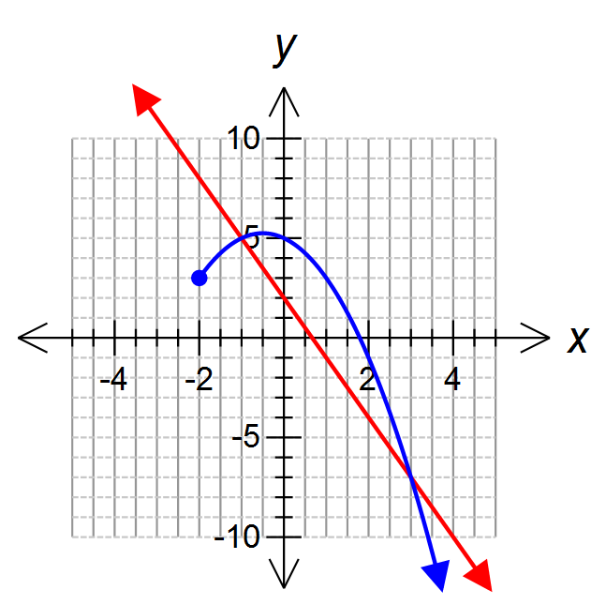

1. Calculate $f(10)$ (1 mark)
2. Determine $k$, if $f\left(k\right)=g(k)$ (2 marks)

1. State the domain and range of $g(x)$ (2 marks)

**Question 12 8 marks**

1. The graph of $y=f(x)$ is shown on each graph below. Neatly sketch and label the following functions on each graph. (4 marks)

|  |  |
| --- | --- |
| $f\left(x\right)+3$ | $f(2x)$ |
| $2 f\left(x+4\right)$ |  |

1. Describe in order the transformations required to change the graph of $y=\frac{1}{x}$ into the graph of $y=\frac{2}{-x+3}$. (4 marks)

**Question 13 3 marks**

The following diagram represents the main structure of a crane. AC is horizontal.   
Calculate the angle of elevation of the point B from A.



**Question 14 2 marks**

Show algebraically that $\sin\left(2θ\right)=2\sin{θ}\cos{θ}$.

**Question 15 7 marks**

1. Aaron Sandilands likes to wear odd socks at training and has 4 different colours to choose from: red, green, purple and white. List the different colour combination pairs he can make from the colours listed. (2 marks)

1. The Fremantle Dockers have 46 players at their club and need to select 3 emergency players for each game. How many different groups of 3 could be selected as emergencies? (1 mark)
2. There are 16 experienced players and 12 younger players fit for selection at the Dockers this week. How many ways can the team be selected if 12 experienced players and 10 younger players need to be chosen? (2 marks)
3. The leadership group at the Dockers consists of 4 players. The club has been asked to send some of the leadership group to a media conference tonight and needs to decide whether to send some, all or none of the players. How many combinations of players from the leadership group are possible? (2 marks)

**Question 16 4 marks**

Data was gathered at Betty’s Jetty on the variation of the height of the water level, $w(t)$, $t$ hours after midnight and measured in metres. The graph of this variation is shown below:

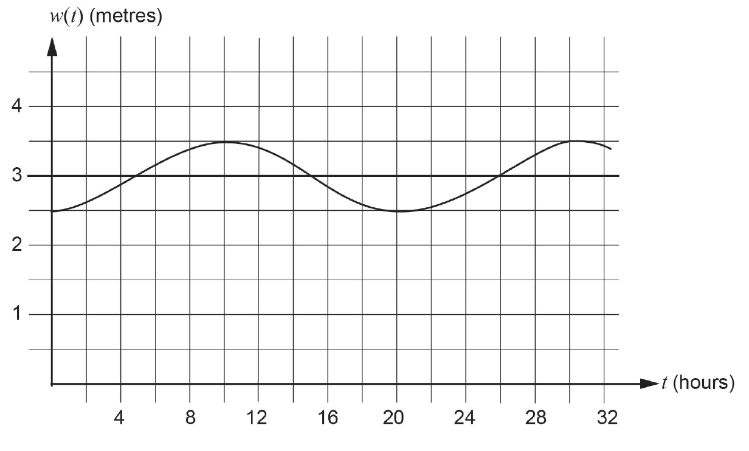

The graph shows initially that the water level was at low tide. The trigonometric function

$w\left(t\right)= -a cos(bt) + c$ is used to model the variation in the water level.

1. Explain, with reasoning, why a = 0.5, b = $\frac{π}{10}$ and c = 3. (3 marks)

1. How many hours after midnight is the water level first at high tide? (1 mark)

**Question 17 7 marks**

The table below displays some data on road crashes in Western Australia for the ten years 1995 to 2004. The road crashes are classified as:

* single-vehicle crashes, e.g. a car hits a tree, or multiple-vehicle crashes (two or more vehicles)
* being in Perth or outside Perth.

**Number of road crashes in Western Australia (nearest thousand), 1995–2004**

|  |  |  |  |
| --- | --- | --- | --- |
|  | **in Perth** | **outside Perth** | **Total** |
| **Single-vehicle** |  | 29 000 | 64 000 |
| **Multiple-vehicle** | 274 000 |  |  |
| **Total** | 309 000 |  | 376 000 |

1. Complete all sections of the table above. (2 marks)

1. What is the probability that a road crash chosen at random from the data involved: (3 marks)
2. multiple vehicles?
3. multiple vehicles and was in Perth?
4. multiple vehicles given that it was in Perth?
5. Does the data collected suggest that multiple vehicle crashes and crashes in Perth are independent events? Justify your answer. (2 marks)

**END OF BOOKLET 2**

This page may be used for extra working space:

Question: ______

This page may be used for extra working space:

Question: ______